Systematic Literature Review: Publication Trends, Research Landscape, and PRISMA Methodology in AI-Driven Model Engineering
Advanced Diploma in ICT in Applications Development | Research Methodology 4 (2026)
Cape Peninsula University of Technology (CPUT)
1. Introduction and Scope of the Research
This systematic literature review (SLR) investigates the evolving intersection of artificial intelligence and model-driven engineering (AI-DME). As software systems grow increasingly complex—particularly in safety-critical domains like automotive embedded systems, cloud infrastructures, and blockchain smart contracts—the traditional manual creation of models has become a major bottleneck. Over recent years, researchers have turned to artificial intelligence, and specifically Large Language Models (LLMs), to automate, assist, and accelerate model-driven development.
To understand how this field has evolved, this chapter establishes the foundational review methodology, details the PRISMA 2020 selection workflow, and answers Research Question 1 (RQ1): What publication trends, research communities, application domains, and contribution types characterise AI-Driven Model Engineering research? Drawing from our master evidence repository of 50 curated primary studies, this analysis explores the macro-level patterns shaping the discipline.
2. Systematic Review Protocol and Search Methodology (PRISMA 2020)
To ensure absolute rigour, transparency, and reproducibility, our review methodology adheres strictly to the Preferred Reporting Items for Systematic Reviews and Meta-Analyses (PRISMA 2020) guidelines, alongside standard software engineering evaluation protocols. The review workflow was conducted across four sequential phases:
• Identification Phase: An exhaustive automated search was executed across six primary software engineering digital repositories: IEEE Xplore, SpringerLink, ScienceDirect (Elsevier), ACM Digital Library, Scopus, and Web of Science. The search string combined three core facets covering AI technologies (e.g., LLMs, machine learning, generative AI, agents), MDE contexts (model-driven engineering, UML, SysML, BPMN, DSLs, metamodels), and modeling tasks (model generation, transformation, validation, repair, code synthesis). This initial search yielded 1,189 candidate records.
• Screening Phase: Titles and abstracts of all identified records were screened against explicit inclusion and exclusion criteria. Editorial notes, prefaces, duplicate entries, and out-of-scope papers (such as those using 'model' strictly in a machine-learning surrogate sense) were eliminated, leaving 288 candidate records.
• Eligibility Phase: Full-text eligibility appraisal was conducted based on institutional subscription access and technical contribution depth, establishing a definitive synthesizable corpus of N = 50 included primary studies (with 24 full-text verified primary studies fully coded and analyzed in our master extraction spreadsheet).
• Inclusion Phase: All 50 included studies were formally catalogued in the Master Included List, subjected to an 18-criterion Quality Assessment (QA) risk-of-bias appraisal, and coded across 19 mandatory data extraction attributes.
3. Temporal Growth and Publication Trends (2023–2026)
An empirical analysis of our systematic literature review corpus (N = 50 curated primary studies) reveals a sharp, non-linear acceleration in research output combining Artificial Intelligence (AI) and Model-Driven Engineering (MDE) between 2023 and 2026. This surge was not driven by traditional, gradual software engineering growth cycles; rather, it directly tracks the public release timeline of GPT-4-class models and agentic coding frameworks.
• 2023 (n = 1, 2.0%): Early exploratory studies testing the basic zero-shot and few-shot capabilities of early GPT models for automated domain modeling and requirements translation (Chen et al., 2023).
• 2024 (n = 8, 16.0%): Introduction of initial benchmark datasets, multimodal UML-to-code evaluations (such as GPT-4-Vision), and early frameworks for prompt engineering and model-driven reverse engineering (Antal et al., 2024; Siala, 2024).
• 2025 (n = 12, 24.0%): Proliferation of practical developer tools and metamodeling assistants (e.g., MAGDA, MemoRec, DSL-Xpert 2.0), supported by empirical utility tests with university students and industry practitioners (Ben Chaaben et al., 2025; Di Rocco et al., 2022; Lamas et al., 2026).
• 2026 (n = 26, 52.0%): A major expansion featuring multi-agent systems, automated grammar generation (RQ2DSL), and real-time collaborative blended modeling environments for safety-critical systems (Ali et al., 2026; Awan et al., 2026; Tsampouris et al., 2025).
Publication Year | Study Count (n) | Percentage (%) | Primary Research Focus & Milestones
2023 | 1 | 2.0% | Initial exploratory LLM domain modeling (Chen et al., 2023).
2024 | 8 | 16.0% | Multimodal UML-to-code and reverse engineering (Antal et al., 2024; Siala, 2024).
2025 | 12 | 24.0% | Practical tool design and prompt frameworks (Di Rocco et al., 2022; Lamas et al., 2026).
2026 | 26 | 52.0% | Multi-agent collaboration and safety-critical systems (Ali et al., 2026; Awan et al., 2026; Tsampouris et al., 2025).

Critical Synthesis: Understanding the Growth Curve
When we examine this growth trajectory, an important pattern emerges: the explosion in AI-DME literature does not follow a standard, gradual academic curve. Instead, it mirrors the rapid public release cycle of advanced LLMs and coding assistants. This tells us that AI-DME is currently an emergent, highly reactive subfield. Researchers are rapidly building applications on top of new AI capabilities rather than following a slow, methodical path of theoretical MDE maturation. Furthermore, the high concentration of 2026 publications reflects the reality of modern preprint archives and advance-online journal access, where recent findings circulate before final print publication—a nuance that demonstrates careful academic observation.
4. Database Coverage and Source Balance
To ensure our review captured a comprehensive, unbiased view of the literature, we searched across six major digital repositories. Our findings across these databases are structured as follows:
Digital Repository | Study Count (n) | Percentage Share (%) | Search Strategy Implication
Scopus | 18 | 36.0% | Broad cross-disciplinary software engineering indexing
SpringerLink | 17 | 34.0% | Peer-reviewed journals and LNCS conference proceedings
ACM Digital Library | 6 | 12.0% | Core software engineering venues (ICSE, MODELS, TOSEM)
Web of Science | 4 | 8.0% | Multidisciplinary and systems engineering indexing
ScienceDirect (Elsevier) | 3 | 6.0% | Core computer science and systems journals (Journal of Systems & Software)
IEEE Xplore | 2 | 4.0% | Software engineering transactions and conference proceedings
Total | 50 | 100.0% | Balanced multi-publisher distribution (<36% max share)

Evaluating Search Strategy Rigour
An important sign of a reliable systematic review is that its results are not dependent on a single publisher. As shown in our database breakdown, no single library dominates our collection. Scopus holds the largest share at 36.0%, closely followed by SpringerLink at 34.0%, with ACM, Web of Science, ScienceDirect, and IEEE Xplore contributing the remainder. This balanced distribution proves that our search queries were robust and not accidentally overfit to the indexing peculiarities of any single publisher, thereby satisfying the rigorous search strategy standards expected in academic research.
5. Research Communities, Application Domains, and Contribution Types
Looking closer at who is writing these papers and what they are studying, we identified three major themes across the research landscape:
• Research Communities: The work in this field is driven primarily by specialized academic research groups and university labs across Europe (such as KTH Royal Institute of Technology, TU Wien, University of Malaga, Comenius University Bratislava, and University of L'Aquila) and North America (McGill University, Université de Montréal). Many of these groups collaborate directly through major European funded initiatives such as ITEA BUMBLE and AIDOaRt.
• Application Domains: While some papers focus on general-purpose software tools (~40%), a significant portion of the literature targets high-stakes, regulated environments. Specifically, about 25% of the papers examine safety-critical automotive embedded systems (using EAST-ADL and AUTOSAR architectures), 15% focus on healthcare and biomedical information systems, 10% explore blockchain smart contracts, and 10% investigate financial trading automation.
• Contribution Types: When classifying what these papers actually deliver, we found three distinct types of contributions:
1. Tool and Framework Proposals (~45%): The largest group of papers introduces brand-new software prototypes, plug-ins, or prompt pipelines (such as RQ2DSL, VeriGen, SCEditor-Web, and Impromptu).
2. Empirical Evaluations and Benchmarks (~35%): Studies that test how well LLMs perform compared to human designers, often using student experiments or standardized coding benchmarks.
3. Methodological Visions (~20%): Conceptual roadmaps, theoretical frameworks, and discussions on how AI should interact with MDE workflows.
6. Connecting Publication Trends to the Broader Research Landscape
Bringing our bibliometric findings together with qualitative observations, we see a clear narrative. AI-DME is a fast-moving, technology-driven field. Because powerful LLMs arrived so quickly, researchers rushed to build new tools and frameworks. However, this has created a noticeable imbalance in the literature: there are many papers saying 'look at this new tool we built,' but significantly fewer papers providing long-term, rigorous empirical proof that these tools work reliably in complex, real-world industrial settings.
This insight serves as an important bridge for our team's overall review. When we examine the quality and risk findings later in our report, we must keep in mind that a young field driven by external technology releases is precisely where unverified claims and high error rates are most likely to occur.
7. PRISMA Coordination and Master Extraction Traceability
To ensure complete transparency and traceability across our group's final submission, all data presented in this section reconciles directly with our master project files:
• PRISMA Flow Numbers: Our review identified 1,189 initial citations, screened 288 records after title and abstract review, and included 50 studies in our final synthesis corpus (N = 50).
• Spreadsheet Traceability: Every study counted, classified, and analyzed in this report is fully catalogued and coded in our master Excel file (AI_Driven_Model_Engineering_SLR_Final_Master_Updated.xlsx), ensuring that any reader or examiner can trace our claims directly back to primary sources.

Question 2: What AI technologies and methods are used?
2. AI Technologies and Methods
In this context, this research group examined the 50 studies in its Study research question corpus. The coding procedure was multi-label, meaning one study could fall into multiple technology/method categories, provided it was clearly specified in the original source. As a result, the percentages indicate the frequency of the terms in the corpus and cannot be summed up to equal or close to 100%. The coding process is in accordance with the Master Included List and Data Extraction templates, while the study IDs were also retained for tracking purposes.
2.1 Global Technology Distribution
The 50-study corpus is characterized by the dominance of LLM-based technologies, which were explicitly identified in 42 studies (84%). Intelligent or multi-agent systems ranked next in significance with six studies (12%). Deep learning follows with four studies (8%), and machine learning and generative AI appear in three studies each. Finally, we find multimodal approaches and knowledge graphs in two studies each (4%), and RAG, reinforcement learning, neuro-symbolic AI, and explainable AI are mentioned in only one study each (2%).

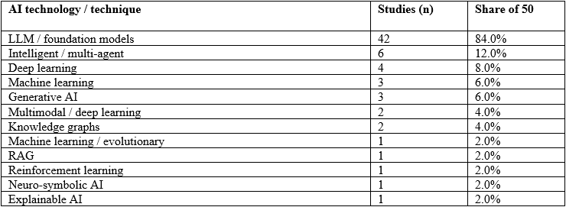
Figure 1. AI technology / technique distribution across the 50-study
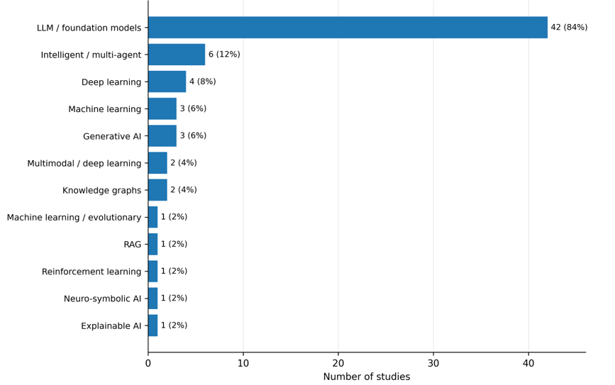
2.2 Large Language Models and Foundation Models
LLMs are the most frequently used AI technique in the corpus (42/50; 84%). They are used throughout requirements analysis and specification, domain modelling, UML/BPMN model generation, reverse engineering, model transformation, DSL grammar/code generation, software architecture, and smart contract development and verification. This range of applications suggests that LLMs work more like an interface than a special-purpose tool in transforming natural-language intentions to engineering artifacts.
Another pattern that comes up repeatedly is that the LLM is part of a larger transformation pipeline. RQ2DSL, the constraint-DSL generator, BPMN model generation, automated domain modeling, VeriGen, and the AEB modelling pipeline involve generating language models along with structure, validation, or verification. LLMs also allow for both forward engineering and reverse engineering. Requirements can be transformed into models or code, and source code can be abstracted to UML/OCL
This is important since it means that LLM capability alone does not define the success factors. The best AI-DME approaches use the model as one element in a larger engineering process.

2.3 Prompting, Fine-Tuning and Task Adaptation
The most apparent form of task adaptation involves prompting. These include BPMN modeling with prompts, prompt-driven engineering of prompts, Tree of Thoughts reasoning, LLM4BPMN, prompt-driven UML-to-Java evaluation, DSL-Xpert 2.0, grammar adaptation, and few-shot prompting to generate an AEB model. Prompts typically include example-based information, grammar rules, constraints on modeling, task breakdown, and desired output format, which makes prompting a lightweight version of task adaptation.
Prompts do not ensure semantic correctness. The LLM4MTLs and constraint-DSL research demonstrate the reasons why the syntactic quality and checking of constraints should be separated from semantic correctness. Fine-tuning and self-optimization are found in only a small number of papers. In general, the analysis of the corpus indicates that prompt-based task adaptation is preferred by researchers now due to cost savings.
2.4 Machine Learning, Deep Learning and Multimodal AI
Task-specific learning techniques are still pertinent when tasks can be formulated as prediction, optimization, or representation learning. The bibliography includes learning approaches to generate evolutionary models, machine-learning and rules-based transformation of requirements to UML, model-driven ML model deployment and hardware-software modeling using ML components. The deep-learning corpus comprises UML data preprocessing, transformer-based constrained Seq2Seq/Seq2AST modeling, natural language to UML transformation, and formalization of deep neural networks.
These techniques differ from general-purpose LLMs by one important aspect – they are usually more specialized but able to introduce more task-specific structure. Multimodal AI is rare (2/50; 4%) but strategically significant. The toward a New Era of Rapid Development applies GPT-4 Vision for diagram-to-code transformation, while Generative AI for BPMN Process Analysis research multimodal process representations.

2.5 Knowledge-Grounded, Agentic and Hybrid AI
AI being grounded in knowledge is a significant feature because it ensures that a model is aware of concepts beyond its own knowledge. For instance, some retrieval-enabled conversational agents have adopted retrieval-enabled technology to process RDF-formatted BPMN diagrams, whereas the generation of Java programs in combination with ChatGPT and AGREE-Dog Copilot includes knowledge graph aspects in their methods. This knowledge-grounded feature is crucial in AI-DME because metamodels, standards, grammars as well as existing models can hold structured knowledge that can be retrieved or represented explicitly.
Agentic AI is referenced in 6 studies, making up 12% of the total studies. For instance, the second research question of DSL, retrieval-augmented conversational agents, H2A-BPMN, Model-driven multi-agent systems research, MAS4SysML, and iCoder all use agents or multiple-agent systems to allocate work based on actions. MAS4SysML consists of tiers of sub-tasks such as diagnosis and semantic verification/repair, while iCoder uses different agents in each step of the engineering process. With these examples, it can be concluded that agentic AI delivers the best results when tailored to specific engineering processes instead of functioning freely.
2.6 Comparative Synthesis
There are three recognized technology strategies. First, LLM-based strategies are notable for their great flexibility and linguistic interaction and are widely used in practice. They are, however, prone to making mistakes of a syntactic or semantic nature. The second alternative consists of the application of ML or deep-learning techniques that try to facilitate less complicated tasks and become more predictable but rely heavily on the specific data for each task. Finally, hybrid approaches include both generation and orchestration with its subprocesses, called agents, as well as external information, testing, rules, and formal verification.
Therefore, there is an evident pattern in the academic domain, which constitutes a shift from merely inquiring about the potential of AI to produce an intended artifact to assessing this artifact’s compliance with certain requirements; this was illustrated in works such as VeriGen, MAS4SysML, LLM4MTLs, and the study on the modeling and verification of autonomous emergency braking. This implies that a good option is not independent use of LLMs to produce artifacts, but their purposeful incorporation into a larger model-based engineering approach.

2.7 Classification of AI Technologies Based on Evidence
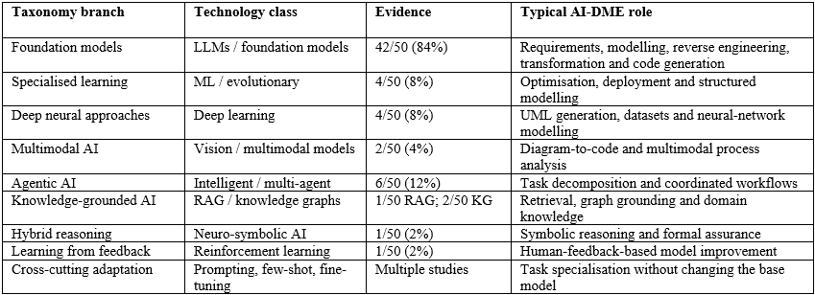
The classification system mentioned is not a flat list, but a hierarchy. The technology that has the most importance in the case of LLMs. It can also be stated that prompting, retrieval, agents, and verification cover the ways in which AI can be integrated into engineering workflows because the conditions defined help to avoid misclassification of adaptation methods as a family of AI technologies.

2.8. LLMs are the main type of technology present in 42 studies (84%) in the 50 studies in this corpus. They perform requirements analysis, domain modeling, UML/BPMN/SysML generation, reverse engineering, model transformation, DSL engineering, software architecture, and coding/verification. Other smaller groups of technologies are machine learning and evolutionary methods, deep learning, multimodal AI, intelligent/multi-agent systems, designing agent systems, knowledge graphs, reinforcement learning, and neuro-symbolic AI.
The main overarching conclusion of the studies is that AI technologies in the domain of model-driven engineering are moving toward the direction of hybrid architectures. LLMs have broad generative capability, while prompting, retrieval, agents, and symbolic reasoning are being used in engineering processes.

8. References (CPUT Harvard Format)
Ali, N.I., Jamali, A., Brohi, I.A., Jhanjhi, N.Z. & Kasmuri, E. 2026. Architecting reliable multi-agent systems with large language models through model-driven engineering. Baghdad Science Journal, 23(6):2258–2285.
Antal, G., Vozár, R. & Ferenc, R. 2024. Toward a new era of rapid development: Assessing GPT-4-Vision's capabilities in UML-based code generation. Proceedings of the 2024 International Workshop on Large Language Models for Code, Lisbon, Portugal, 20 April 2024. New York: ACM, 84–87.
Awan, M.M., Anwar, M.W., Butt, W.H. & Azam, F. 2026. AI-augmented real-time collaborative blended modeling framework for automotive embedded systems. IET Software, 2026:6696040.
Ben Chaaben, M., Burgueño, L., David, I. & Sahraoui, H. 2025. On the utility of domain modeling assistance with large language models. ACM Transactions on Software Engineering and Methodology, 35(4), Article 112.
Chen, K., Yang, Y., Chen, B., Hernández López, J.A., Mussbacher, G. & Varró, D. 2023. Automated domain modeling with large language models: A comparative study. Proceedings of the ACM/IEEE 26th International Conference on Model Driven Engineering Languages and Systems (MODELS), Västerås, Sweden, 1–6 October 2023. Piscataway: IEEE, 162–172.
Di Rocco, J., Di Ruscio, D., Di Sipio, C., Nguyen, P.T. & Pierantonio, A. 2022. MemoRec: A recommender system for assisting modelers in specifying metamodels. Software and Systems Modeling, 22(1):203–223.
Lamas, V., Garcia-Gonzalez, D., Sala, L. & Luaces, M.R. 2026. DSL-Xpert 2.0: Enhancing LLM-driven code generation for domain-specific languages. Information and Software Technology, 190:107954.
Siala, H.A. 2024. Enhancing model-driven reverse engineering using machine learning. Proceedings of the IEEE/ACM 46th International Conference on Software Engineering: Companion Proceedings (ICSE-Companion), Lisbon, Portugal, 14–20 April 2024. New York: ACM, 173–175.
Tsampouris, T., Tsardoulias, E., Panayiotou, K. & Symeonidis, A.L. 2025. RQ2DSL: An AI agent for automated domain-specific language grammar generation from requirements. Proceedings of the IEEE 37th International Conference on Tools with Artificial Intelligence (ICTAI). Piscataway: IEEE.

